|  |  |
| --- | --- |
|  | **Qatar University**  **College of Engineering**  **Department of Computer Science and Engineering** |

Operating Systems-(CMPS 450)

**Task: Project Phase 1**

*Fall 2024*

**Project Group Members:**

Marwan Hashish ID:201701546

Abdulla Jamali ID: 202104080

Nasser Aljufairi ID: 202005009

Murshed Al-Muhannadi ID: 201706102

**Instructor**: ***Eng.Heba Dawoud***

|  |  |  |
| --- | --- | --- |
| **student name** | **Student part in the Project** | **participation percentage** |
| Marwan Hashish |  |  |
| Abdulla Jamali |  |  |
| Nasser Aljufairi |  |  |
| Murshed Al-Muhannadi |  |  |

**Task 1: Setup Server side (VM1)**

**-Create users on the server (client 1, client2)**

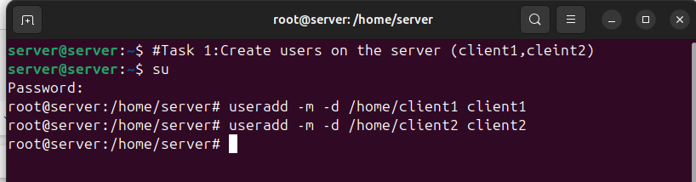-Setting passwords for client1 & client2

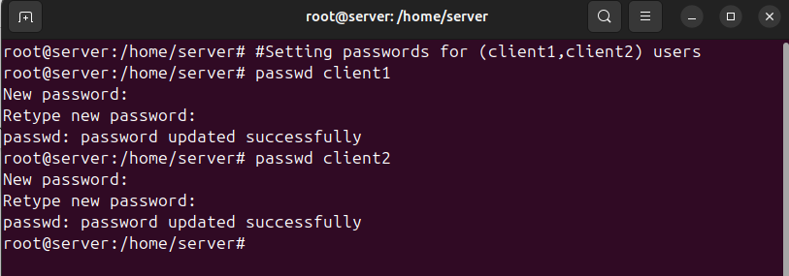-Checking that users are created (client1, client2):

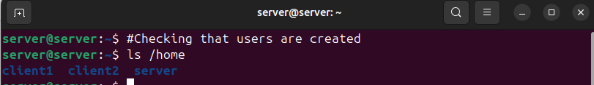

**-Install and enable SHHD**

-Checking if SSH is installed

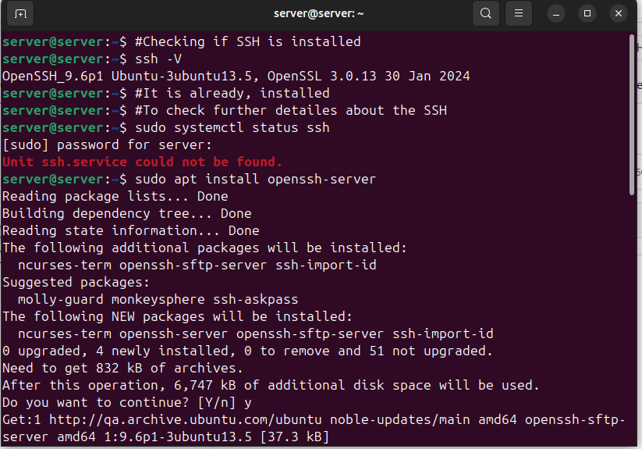-Check if SFTP is working

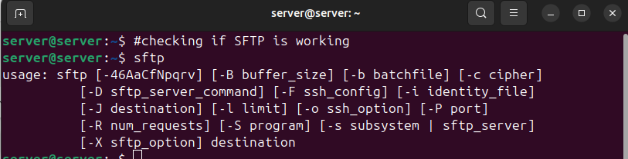

**Task 2 : Configuration**

To Get the IP of the server we did:

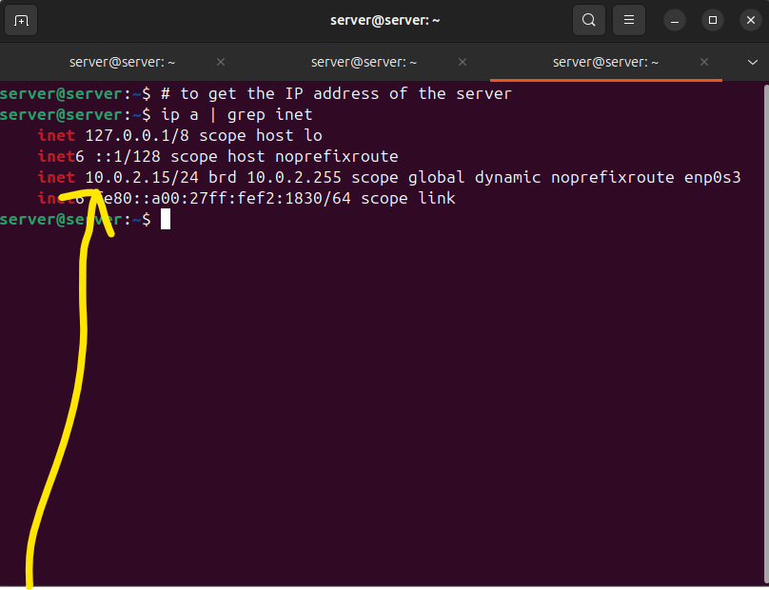

Accessing the server from client 1 using SSH and the ip address of the server we just retrieved:

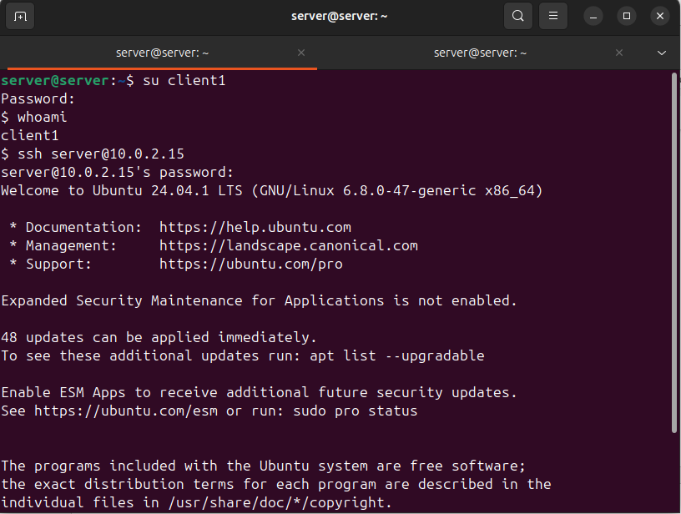

We managed to access the server using SSH (remotely) by client1 user:

-We deduce that SSH is enabled successfully for client 1, we now will do the same for client2:

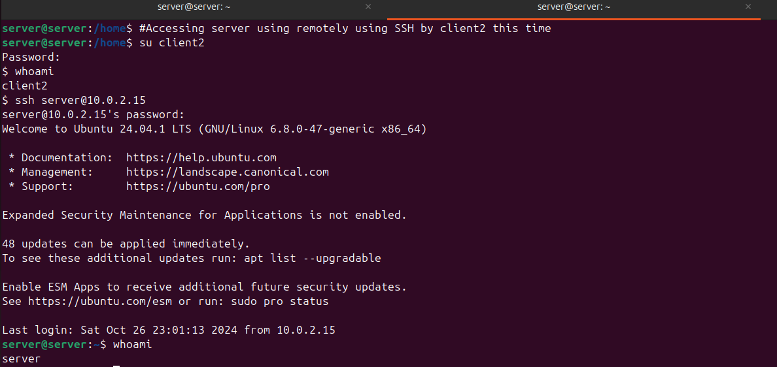

-We deduce that SSH is enabled successfully for client 2

-Checking the SCP is working

